Set Checking Tool User Guide
Step 1: Execute Transaction in SAP
- Open SAP and navigate to the T-Code ZIRN_VIEW_LINES.
- Enter your plant code & choose desired date range. Execute the transaction to display the required data.
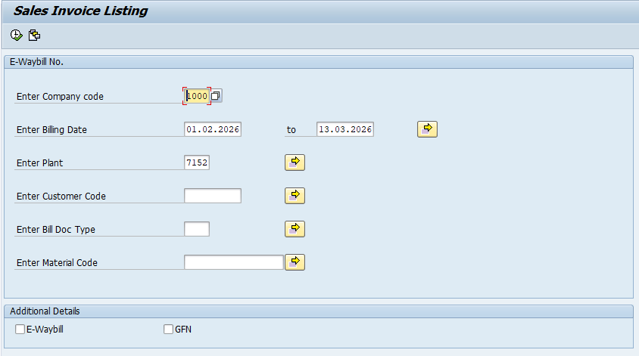
Step 2: Sort the Customer Code column in Ascending Order to ensure proper grouping and analysis by the tool.

Step 3: Set & Save Layout
- Make sure the layout contains below required columns for the tool to function correctly:
  - SOF
  - Document No.
  - Bill Date
  - Customer Code
  - Customer Name
  - Town
  - Material Code
  - Description
  - Quantity
- Select & Hide other non-required columns for clean dataset & faster export data into excel.
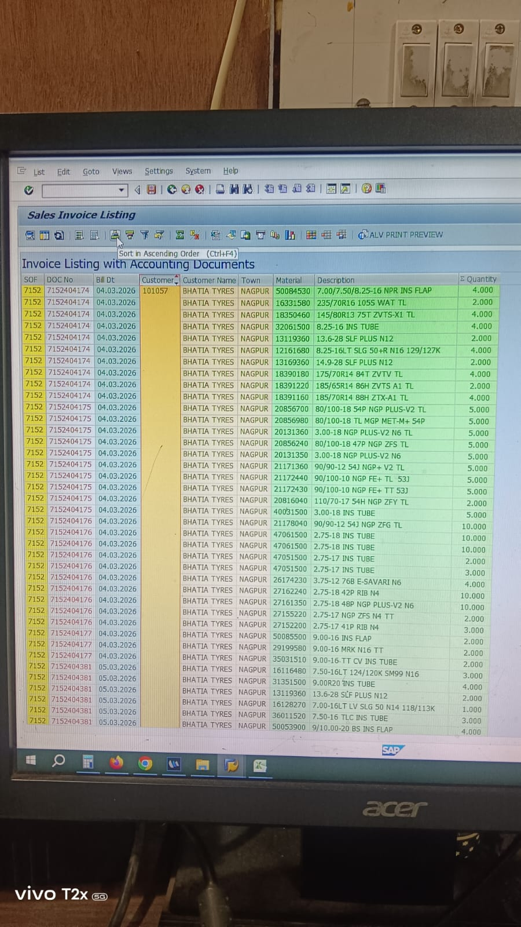

Step 4: Save this layout for future use. Since this T-Code does not support global layout selection, we need to create and save user specific layout for each ID. This allows the same layout to be reused for future executions.

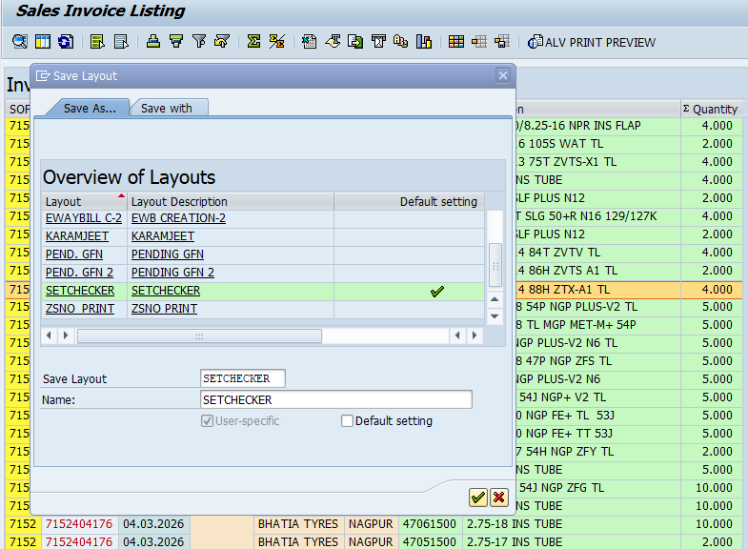

Step 5: Export Data
- Right-click anywhere in the generated data grid table.
- Select Export and choose and choose Spreadsheet. Save the file to your desired location.
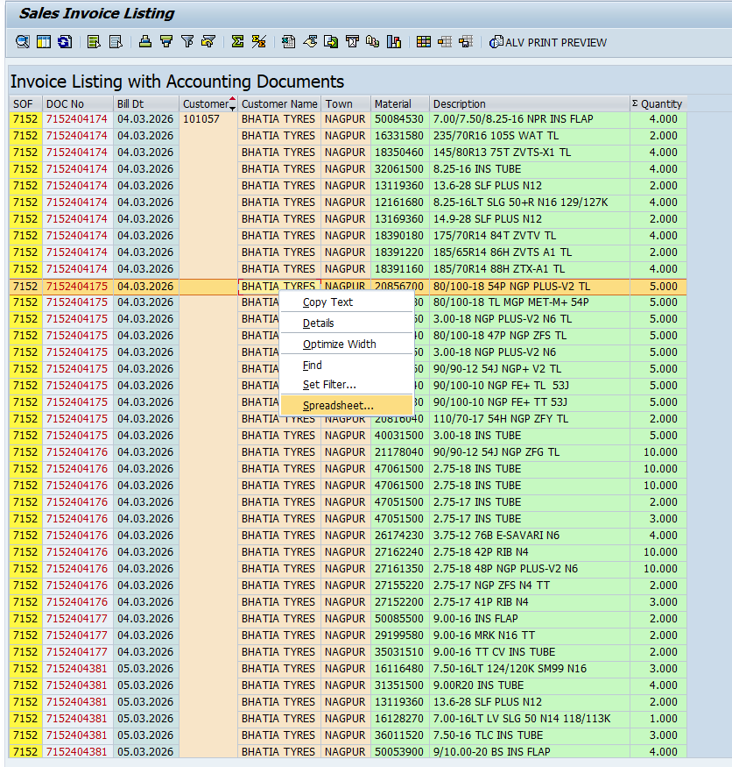

Step 4: Open Exported File
- Once the spreadsheet launches automatically, navigate to the "M R F" tab, which is located next to the Home tab in Excel ribbon.

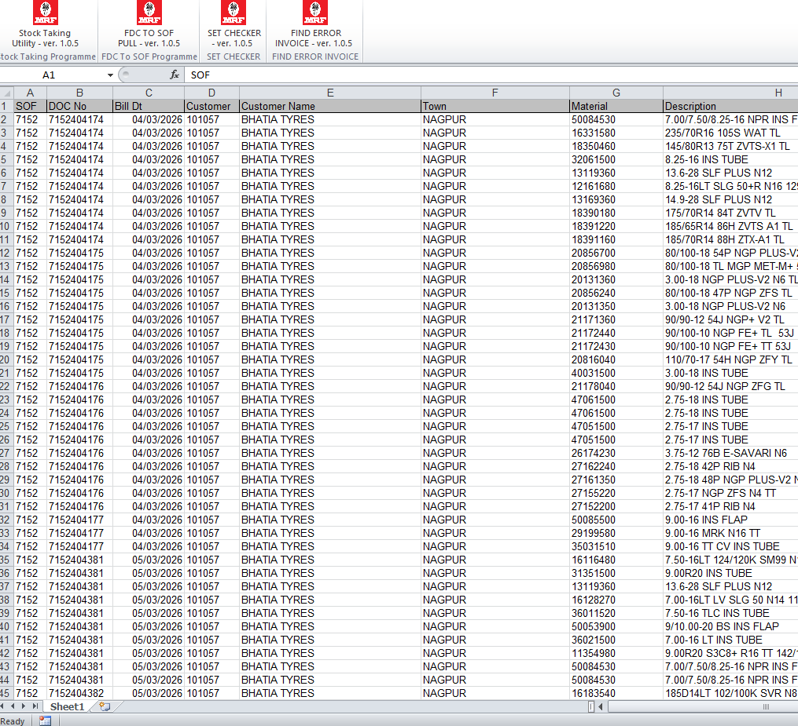

Step 5: Run the Set Checker
- Under the "M R F" tab, click on the "Set Checker" icon.
- The tool will execute the necessary checks and complete the process. Navigate to the newly auto-generated “Billing Errors” worksheet to review and process any identified discrepancies.

Phase 2: Execute Deep Scan - Find Error Invoice
Step 6: Error Isolation & Detailed Review
- If any discrepancies were flagged via Set Checker, return to the “M R F “tab and click the “Find Error Invoice” icon.
- Allow the tool to complete its checks. Once finished, use the newly generated hyperlinks within the Billing Errors sheet to navigate directly to individual size sheets. This will allow you to pinpoint the exact mismatched invoice numbers and their corresponding dates.

